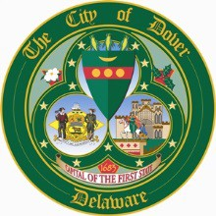

SILVER LAKE COMMISSION
Meeting will be held in person and via weblink.

Meeting Link: https://cityofdover.webex.com/cityofdover/j.php?MTID=m3c630f82c978ffd12925350ac3f6e3c7

Dial: 1-650-479-3208 Access code: 2531 462 5155 Event password: SLC2026

AGENDA

June 24, 2026
5:30 PM
Large Conference Room

AGENDA

- Call to Order / Welcome Members

- Review of Minutes (February 5, 2026)

- Dover Police Update (Officer Frye)

- Earth Day Report (B. Wambaugh)

- Explanation of the current Stormwater Management Plan under the MS4 Permit (B. Wambaugh)

- DNREC presentation regarding success stories for water quality improvement and what Dover may be able to adopt

- Silver Lake Master Plan (staff)

- Meeting Schedule (quarterly)

- Adjournment

THE AGENDA ITEMS AS LISTED MAY NOT BE CONSIDERED IN SEQUENCE. PURSUANT TO 29 DEL. C. §10004(E)(2), THIS AGENDA IS SUBJECT TO CHANGE TO INCLUDE THE ADDITION OR THE DELETION OF ITEMS, INCLUDING EXECUTIVE SESSIONS, WHICH ARISE AT THE TIME OF THE MEETING.

